ONE STEP LEARNING (OSL) 2020 – 2024 STRATEGIC PLAN
  - Quality early childhood support for rural children to develop lifelong skills is about collaboration and partnerships. Come let’s work together.You are invited to celebrate an Africa landmark. Put your name and your social values on the plaque to advance children’s education in the Learning through Play Daycare centre in Entumbil, Ghana.
OSL founders have donated a 2012 building and large compound in rural Entumbil, Ghana for Learning through Play daycare for 2 – 6 year olds. Additional sponsors and donors are needed for new or used materials, equipment, volunteers, electronics, toys and cash in order to convert the facilities into a functional daycare centre. A Canadian registered charity, One Step Learning Opportunities Centre (OSL) will manage, direct and control the project. Gift donations are tax deductible.
“Play elevates talent and abilities” – John Hagan

Table of Contents
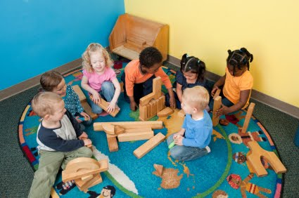 Play Elevates Talent/Abilities 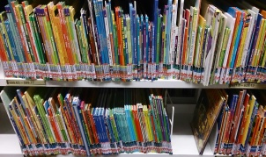 2
INTRODUCTION - The Charitable Path 3
Table 1: Big Picture of Noble Idea 4
Table 2: Summary of Charitable Activities 5
Rural Entumbil Town 9
The Need and the Market 9
“Play elevates talent and abilities” –John Hagan 10
Academic Operational Activity Analysis 11
Evaluation and Quality Assurance Measures 12
Subscribers and Sponsorships 12
Stakeholders’ Opportunities 13
Sponsorship and Partnership Options 13
STRATEGIC FRAMEWORK 14
Context 14
Mission, Vision, Outcomes 14
Legislation, GES and District Assembly 15
Risks, Constraints and Mitigation 15
Strategies 16
Governance Oversight and Management 16
Conversions Required Budget 17
Cash flow summary 17
Materials and Accessories Budget 18
Financial Projections 19
Appendix 1: Founders’ Contributions 19
Appendix 2: Sponsor Funds Needed 19
Business/GST number: 771608478 0
CRA Charity Registration #: ?771608478RR0001? 0
Donation to OSL [taxreceipt@onesteplearning.org] 0
Contacts 0

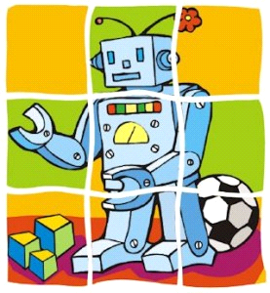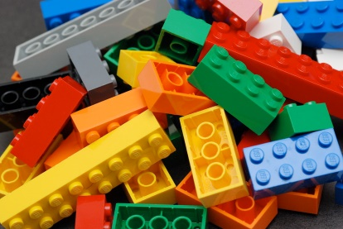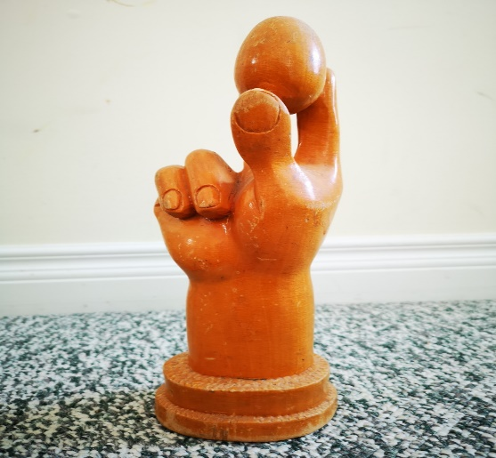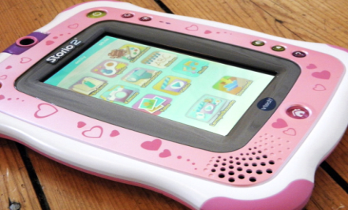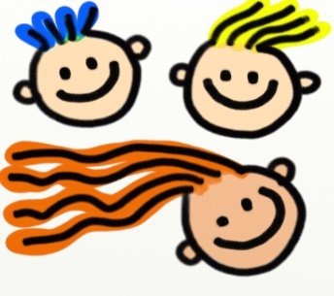

Play Elevates Talent/Abilities

Proposed One Step Learning Preschool Site 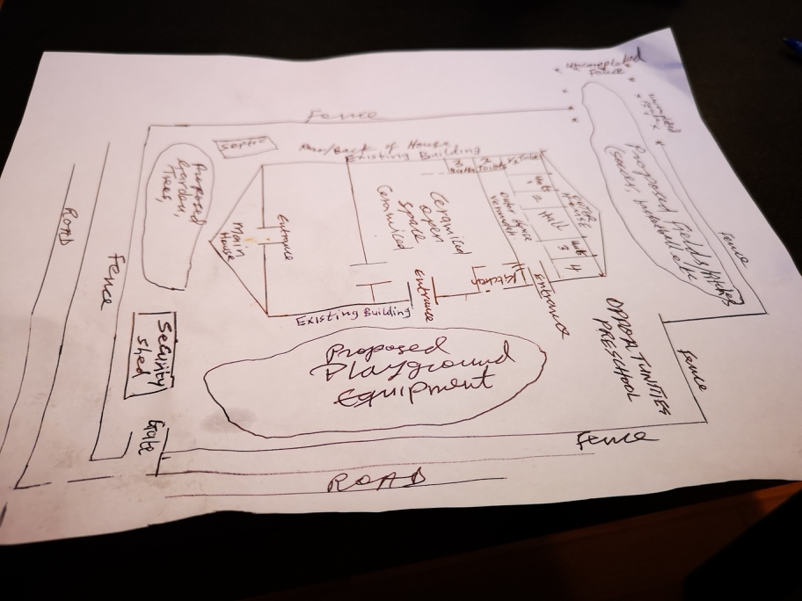 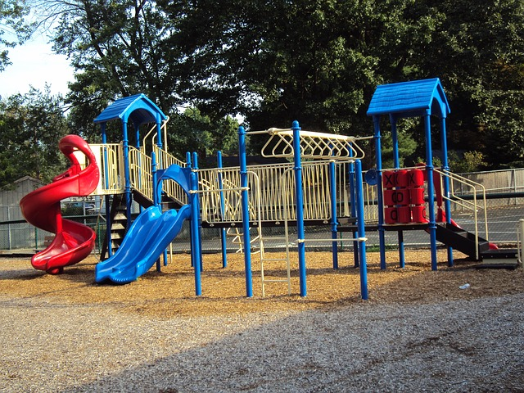
INTRODUCTION - The Charitable Path
To: Partners and Donors October 2020
Dear Sir / Madam
Invitation for Your Participation in Learning through Play Preschool Project
It is commendable that your various studies and contributions have confirmed that Learning through Play, daycares, and other preschool models have all played important roles in shaping a child’s future.
One Step Learning Opportunities Centre (OSL), a Canada Revenue Agency (CRA) registered charity in Edmonton, Alberta Canada is supportive of your values. The charity proposes to take your contributions a step further in an effort to offer lifelong learning opportunities for rural children.
A Canadian couple has donated some US$241,000 in their existing 2012 building and large outdoor compound in rural Entumbil, Ghana for a play-based preschool for 2 – 6 year olds. The facility needs to be converted into an appropriate daycare centre with additional materials and playground amenities.
Opportunities exist for various stakeholders to achieve their social goals and recognition for contributing to rural children’s learning through new or used materials, equipment, services or cash. Sponsors like you and your organization may contribute any of the items listed in Table 2, Appendix 2 and Appendix 1 of the Strategic Plan. Charitable tax deductible receipts are available for your donation in-kind or cash.
OSL is regulated and accountable for all resources received. OSL is open to external audits, Collaborative Agreements, communication updates, progress reports and legislative obligations. OSL is happy to share its 2020–2024 Strategic Plan [here] and milestones. You are invited to visit the facilities or inquire about the opportunity to make informed judgements. Put your name and social values on the centre’s plaque.
One Step Learning Opportunities Centre (OSL) whose goals align with Canada’s international assistance priority objective to empower rural children especially girls, will manage, direct and control the project in Entumbil, Ghana, in order to advance literacy, prosperity and equal opportunity in the community.
You are welcome to refer OSL to other people, organizations and avenues that may be of help.
Contact John Hagan, President, (+1-780-717-4055) with ideas or any questions.
Thank You for your time and generosity.
Sincerely

John Hagan, President
One Step Learning Opportunities Centre Ι Phone: +1 780 717-4055
Email: jcbhagan@telus.net Ι or Ι contact@onesteplearning.org
Website: www.onesteplearning.org

OSL will gladly do a presentation [click here] for you if invited
Table 1: Big Picture of Noble Idea and Ancillary Activities for incorporating OSL as Non-Profit Registered Charity:
Purpose | Means & Needs to the purpose | Proposed Charitable Activities and Resources for OSL purpose include: |  | Learning Through Play Daycare Program & Activities for the purpose
The purpose of One Step Learning Opportunities Centre (OSL) is:  To advance education by establishing, maintaining and operating Learning through Play Daycare Centre in Entumbil Ghana  To undertake activities ancillary and incidental to the attainment of the above-mentioned charitable purpose | Establish a Daycare.  You need Space, Building, washrooms, security, safe playground equipment, materials, logistics and program administration.  Set up a tax charity Play Daycare as rural parents and kids cannot afford  Convert facilities to a suitable and kids safe learning environment  Program will need teachers, volunteers, and support staff and logistics supplies like toys, books, tablets, electronics, lunch plates, food, sanitation and day-to-day learning. | Founders have leveraged building facilities valued at USD$241,000  Seek qualified donors, early childhood sponsors and researchers worldwide who believe in the Learning through Play Daycare models and are willing to support talented poor rural children.  Approach NGOs who operate in Ghana or Africa from Canada, Europe, USA, Africa, Asia and Middle East for support.  Public donors may be interested if you prepare measurable Strategic Plan. Create website and social media.  Ship donated equipment and materials collected to Ghana for use by Daycare.  Carry out the conversion works that needs to be done to bring the infrastructure and compound to a suitable and safe Daycare.  Open the OSL Daycare, accept pupils and run the outlined Program. |  | GOAL: Empower rural children through playful experiences that help them to be happy and healthy in their lives; and develop their skills to be creative, engaged, and lifelong learners of tomorrow.  Stimulating activities in the Curriculum shall include puzzles, building blocks, geometric blocks, board games, drawing, cardboard games, and painting. Digital games and Technology. Environmental studies and community engagement.  Learning through play on the internet and tablet, toys as tools, music, movement, physical exercises, numbers, nature, health, literacy, and corner activities feature daily.  Others include: organized games, dancing patterns, stories, hide and seek, alphabet and numbers activities. Teach nature and hands on activities the children love e.g. landscaping, planting trees, gardens etc.  “Play elevates talent and abilities” – JH
Outcome: Rural children become creative learners. Parents enabled to seek employment or careers. Sponsors and donors values promoted.

The Big Idea: The OSL charitable idea was inspired by news anchor Lawrence O’Donnell of MBNBC TV - The KIND Malawi School Desks Project.
Founders asked ourselves, how we can also help rural poor children under our eyes. We travel to Ghana at least every other year on average.

Table 2: Summary of Charitable Activities related to the Funds Needed for OSL Program
Daycare Charitable Activities/Items  Expenditures | Beneficiary | Value in USD$ | Value in CDN$  @1.35
Leasehold Property – building, space | OSL | 241,000 | 325,350
Daycare Conversion costs & Equipment | OSL | 121,000 | 163,350
Academic: books, teachers, electronics, toys | OSL | 14,000 | 18,900
Program Supplies | OSL | 7,000 | 9,450
Fixed Asset - vehicle, furniture | OSL | 36,000 | 48,600
Sub-Total (241000 + 1780000) |  | 419,000 | 565,650
Fund Raising- rent a table @ 2-3 Early Childhood development events and attend. Meet rural childhood sponsors and follow up with solicitation and meetings | OSL |  | 15,000
Shipping of donations, say 15% x $240,300 | OSL |  | 36,000
Administration in Canada say 8%: Financial records, Intuit QuickBooks $95/m, Microsoft 109/m, legal retainer $2,000, Website $88/m, Telus Intl Security pkg. $500, Phones, Computer supplies, communication needs, travel to Ghana $4,000, others e.g. reimburse volunteers expenses if any | OSL |  | 15,000
Day-to-day Academic Program Expenditures
Utilities & Supplies | OSL | 8 ,000 | 10,800
Teachers & Staff salaries | OSL | 33,000 | 44,550
Facility Maintenance & Repairs | OSL | 4 ,000 | 5,400
Admin, pupils lunch supplies. | OSL | 11,000 | 14,850
Sub Total of daily program expenditure |  | 56,000 | 75,600
Revenue from (Use of Assets) | OSL
Pupils fees | OSL | 28,800 | 38,880
Food fee | OSL | 7,680 | 10,368
Volunteers in-kind, donations | OSL | 19,520 | 26,352
Totals |  | 56,000 | 75,600

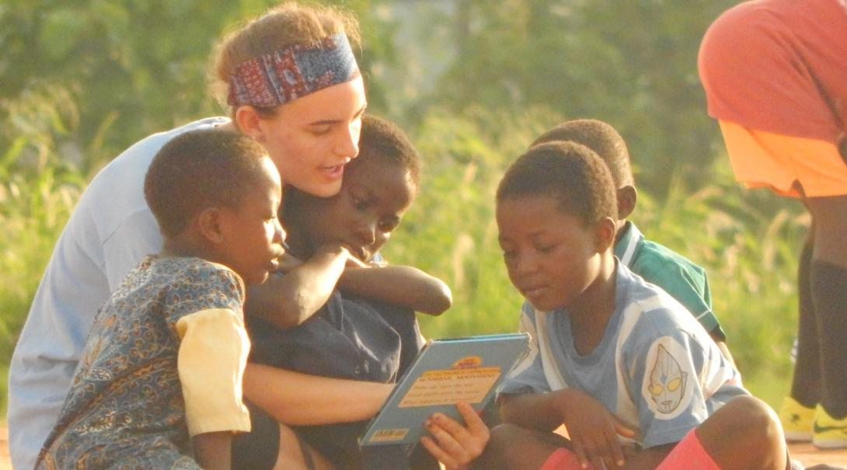
Appendix 1: Founders’ Contributions tagged with related Activity
Items | Value in USD$ | Value in CDN$ @1.35 | Charitable Activity
Founders Existing Contribution  Outer House consists of these: | 241,000 | 325,350 | Leasehold Property
4 identical Rooms/Units 14’x15’ each@ USD$25k x 4 | 100,000 | 135,000 | Leasehold
1 Large Hall for Office Admin & storage etc. 22’x15’ | 50,000 | 67,500 | Leasehold
1 kitchen 15’x15’ | 40,000 | 54,000 | Leasehold
3 Toilets ( 2 for girls, 1 for boys). | 30,000 | 40,500 | Leasehold
3 Bathrooms @USD$7k x 3 | 21,000 | 28,350 | Leasehold
A separate entrance | -- | --
Total existing contribution | 241,000 | 325,350 | Leasehold
Founders Additional Funding :
Finish Fencing & security Qtrs. | 10,000 | 13,500 | Conversion
Boys Peeing Room & Plumbing | 3,000 | 4,050 | Conversion
Used Vehicle SUV/Truck | 25,000 | 33,750 | Fixed Asset
Big Promotion Signage | 2,000 | 2,700 | Conversion
Street access improvement | 1,000 | 1,350 | Conversion
New Painting | 4,000 | 5,400 | Conversion
New Fridge, Stove, Washer &Dry | 5,000 | 6,750 | Fixed Assets
Toiletries | 1,000 | 1,350 | Program Supplies
Plates and Cutlery, Utensils etc. | 2,000 | 2,700 | Program Supplies
Additional Funding contribution | 53,000 | 71,550 | Founders
Grand Total from founders | $294,000 | $396,900 | Leverage
Sweat Equity/Volunteers match | $294,000 | $396,000 | Volunteers

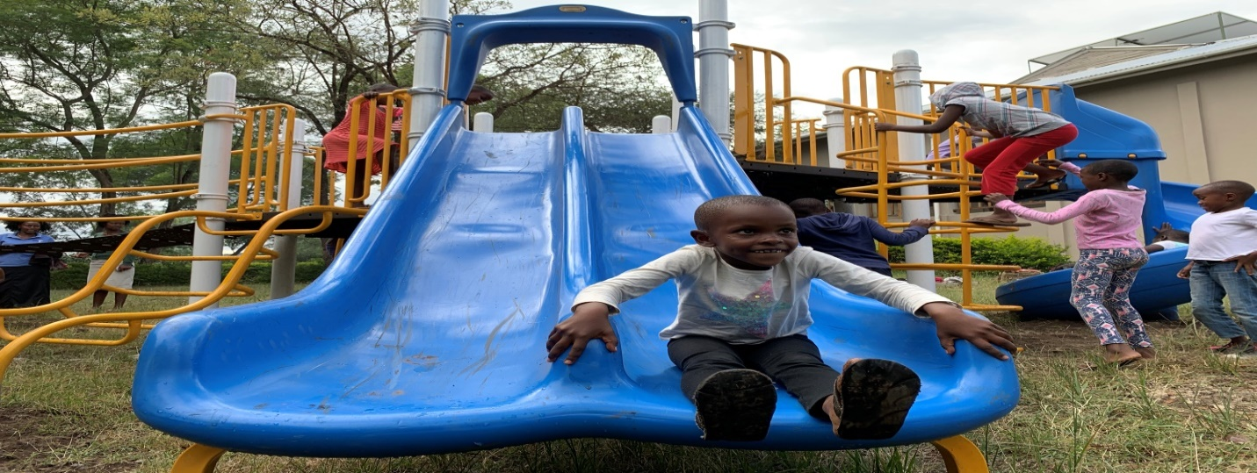
“Play elevates talent and abilities” –John Hagan
Appendix 2: Sponsor Funds needed tagged with related Activity
Items | Value in USD$ | Value in Cdn $ @ 1.35 | Charitable Activity
3rd Party Existing Contributions | 0 - now | 0 - now
Third Party Sponsorship sought:
3rd Party Funding Needed for:
Landscaping Playground | 10,000 | 13,500 | Conversion
Plant trees, Sheds… | 6,000 | 8,100 | Conversion
Playground Equipment | 40,000 | 54,000 | Conversion
Assembly area flooring | 25,000 | 33,750 | Conversion
Extended Roofing | 14,000 | 18,900 | Conversion
School Backyard fields | 6,000 | 8,100 | Conversion
Audio/PA System, TV Monitors | 3,000 | 4,050 | Academic
Electronic & Electric connections | 2,000 | 2,700 | Academic
Classrooms furnishings | 3,000 | 4,050 | Program supplies
Computers, tablets, | 5,000 | 6,750 | Academic
Office furniture, printers, tools | 2,000 | 2,700 | Fixed Asset
Teachers development | 3,000 | 4,050 | Academic
Safety/Emergency /Sanitation | 1,000 | 1,350 | Program Supplies
Toys, gadgets, White Board | 1,000 | 1,350 | Academic
Unit Classrooms furniture | 4,000 | 5,400 | Fixed Asset
TOTAL Sponsorship needs | $125,000 | Cdn$168,750 | Sponsors/Donors
Sweat Equity/Volunteers match | $125,000 | Cdn$168,750 | Volunteers
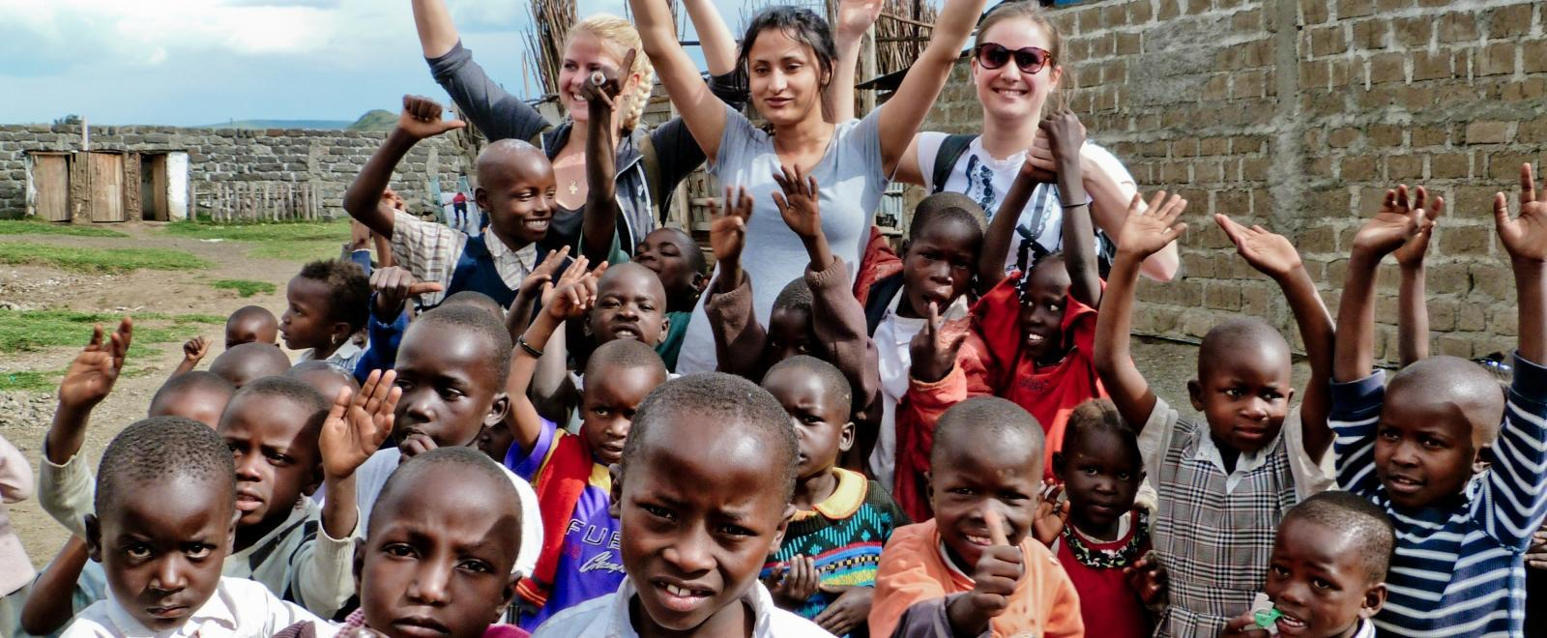
Canada Revenue Agency (CRA) will audit these figures as they materialize. OSL has the leased building and facilities now. Funds raised will be the means to carry out the charitable activities.
In addition, the founders as volunteers too, want to contribute to OSL the tangible items and activities listed in Appendix 1 from Canada for the furtherance of OSL purpose. The founders call that “leveraging” = voluntary contribution and support for a noble and worthy course.
Key Messages
Many studies and contributions have confirmed that Learning through Play, daycares, and other pre-school models have all played important roles in shaping a child’s future. Rural children have potential and pray for opportunities that can unearth their hidden talents and abilities. However, rural communities like Entumbil in Ghana, Africa, lack resources, and infrastructure for childhood learning.
A Canadian couple has donated US$241,000 in an existing 2012 building and large outdoor compound in rural Entumbil, Ghana for a play-based preschool for 2 – 6 year olds. The facility alone is not enough to run a daycare. Therefore, a Canadian tax deductible registered charity, One Step Learning Opportunities Centre (OSL), has been incorporated to undertake charitable activities. OSL purpose is to advance education by establishing, maintaining and operating a Learning through Play Daycare in Entumbil.
Sponsors and donors whose values align with the founders to create learning opportunities for rural children are needed to contribute. Sponsors like you and your organization may contribute or donate any of the materials, equipment and services items listed in Table 2, Appendix 2 and Appendix 1 of this Strategic Plan. The items are needed to convert the facilities into a daycare centre for rural children.
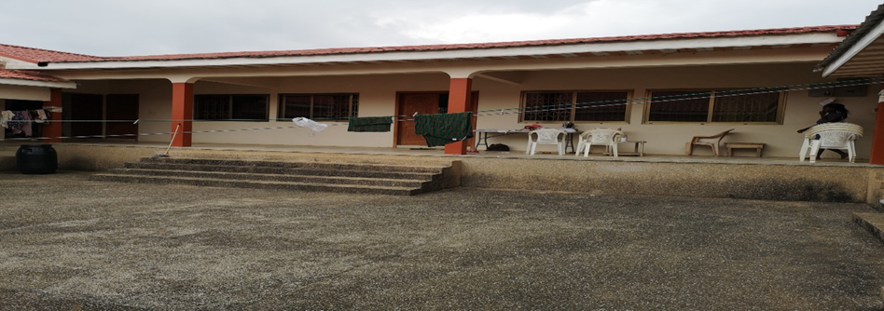
The $241,000 facility is a 2012 self-contained building adjacent to the subscribers’ main house in rural Entumbil. It comes with a separate entrance, 4 large units as classrooms, 1 large hall ideal for administration and storage, 4 toilets, 3 bathrooms, a kitchen, 2 large open space indoor verandahs ideal for corner activities, and huge outdoors compound. The facilities by all early learning and development standards (ELDS) are ideal for a pre-primary centre and can accommodate 120 or more students.
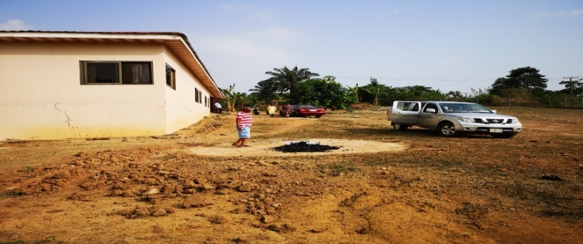
Inspire OSL to elevate rural children's talent & abilities
Project subscribers are very open to external audits, evaluations, Partnership/Sponsorship Agreements with terms and conditions, as well as, periodic progress reports and communication with collaborators.
The expected outcomes include, inspiring early childhood rural children to develop lifelong learning skills. The initiative will also empower the children’s parents to pursue gainful employment and careers. Sponsors have an opportunity to celebrate their social values in this corner of the world.

Rural Entumbil Town
Entumbil is a rural town in central region Ghana, West Africa. Population is 3,500 with some 400 children between the ages of 2 to 6 years old. Entumbil is two hours’ drive from Accra, capital city of Ghana. Distance related to other cities in Ghana include: 90 minutes from Cape Coast, 40 minutes from Swedru/Winneba; three hours from Takoradi, five hours from Kumasi and 10 hours from Tamale. There is no preschool facility for children. Learning through Play is absent. Entumbil is predominantly a farming community. Other scarce employment avenues are a Salvation Army health clinic, a motel, and roadside self-employed retailers. Link for additional statistics can be found at: https://new-ndpc- static1.s3.amazonaws.com/CACHES/PUBLICATIONS/2016/06/06/AJUMAKO+ENYAN+-+ESIAM.pdf

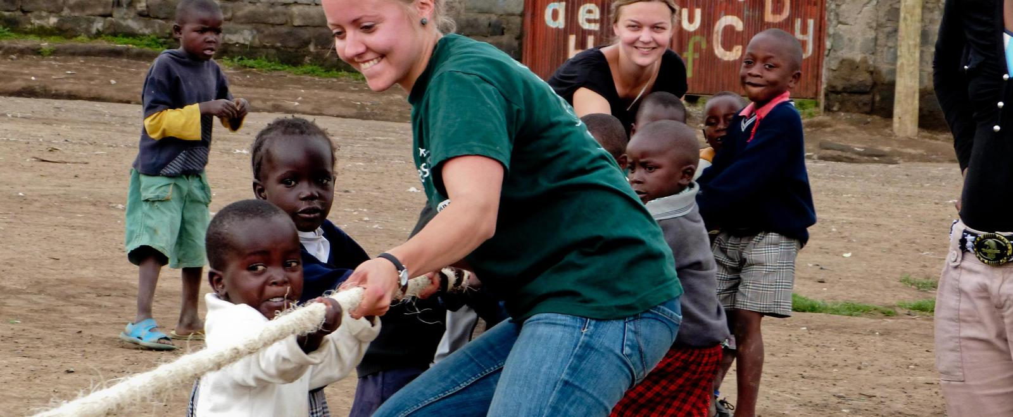

The Need and the Market
There is no day care or any early childhood learning facility in Entumbil now. A daycare with some 180 children opened in Entumbil in 2015 but closed in 2017 due to lack of appropriate accommodation, infrastructure and financial difficulties. Founders are told parents were challenged to pay the monthly preschool fees of GHC$150 (about $40 or USD$30) in the rural town. The closest daycares range from five to ten kilometers away. Those facilities were visited as part of the founders’ research.
Three daycares were identified and explored. They were crowded to the brim, with unit room sizes that range from 40 – 60 pupils and one teacher. There are virtually no appropriate playgrounds, and little infrastructure amenities in those competitors’ facilities. Those conditions were found challenging to give children active experiences with learning in classroom and/or play with materials. Those three facilities have waiting lists that they cannot fill. Founders were told there are over 600 children in Entumbil and surrounding area waiting to gain admission to a daycare centre. The need for preschool facilities is high.
One Step Learning Preschool will feature a playground, lots of space and nature for children to engage in environmental and technology activities. The cornerstone of the preschool will be to provide appropriate play, nutrition, health, sanitation, safety, qualified staff and parental engagement that motivate preschool children to develop their intellectual, social, emotional and physical skills. Class sizes will be monitored to achieve quality and effective teacher and pupils’ ratio balance.

The focus strategy of One Step Learning Preschool is learning through play at the centre, at home and through engagement with peers and the community. The critical role of play in daily living concepts of mathematics, science, literacy and community will be emphasized in building children’s developmental skills. A structured curriculum using playful tools, books, technology, and teamwork will be paramount.
Play-based concepts will be demonstrated in all activities using the right tools and trained human resources. One Step Learning Preschool is intended for rural children 2 – 6 years old. The rural towns cannot afford the GHC$150 – $1,000 per month charged in the bigger Ghana cities. That is the reason why donations and sponsors contributions are needed to support the rural project financially in cash and/or in-kind to kick start the project until it becomes self-sufficient in about three years.

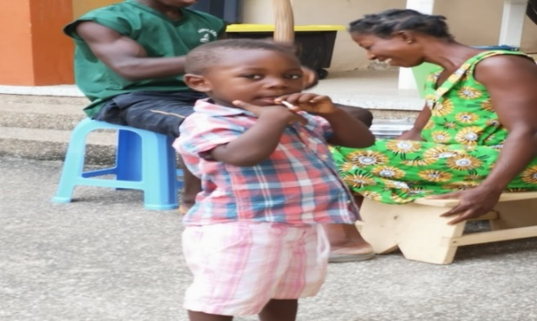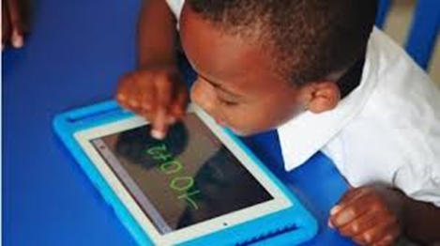

“Play elevates talent and abilities” –John Hagan

OSL will gladly do a presentation [click here] for you if invited

Academic Operational Activity Analysis

The GOAL of One Step Learning is to empower rural children through playful experiences that help them to be happy and healthy in their lives; and develop their skills to be creative, engaged, and lifelong learners of tomorrow. The ultimate expected Result is that the children’s’ preschool years’ experience enables them to explore and make sense of the world around them and its uncertainties, as well as, use play to develop their imagination and creativity in the community.
Programs: Stimulating activities in the curriculum shall include puzzles, building blocks, geometric blocks, board games, drawing, cardboard games, painting, and their related digital toys and electronics. Learning through play on the internet and tablet, toys as tools, music, movement, physical exercises, numbers, nature, health, literacy, and corner activities will dominate daily activities. Other activities include organized games, dancing patterns, stories, hide and seek alphabet and numbers activities. The vast surrounding playgrounds and field spaces around the building will be utilized to teach nature and hands on activities children love e.g. landscape, plant trees, gardening and sports.
Staffing: Employ 12 – 15 qualified people in the community to teach and manage the preschool daily for 9 hours. Open at 7:00 to 16:00 pm. Employment ratio of 70% academic and 30% support staff. Emphasis will be placed on staff development and hiring qualified staff experienced in learning through play concepts and resources, such as using objects children can explore and use in learning. One Step Learning Preschool will help teachers and adults in the room to find and create play materials that are low cost locally produced. The role of teachers would be to provide children with active and playful hands-on experiences that help foster and enrich learning through play in practice.
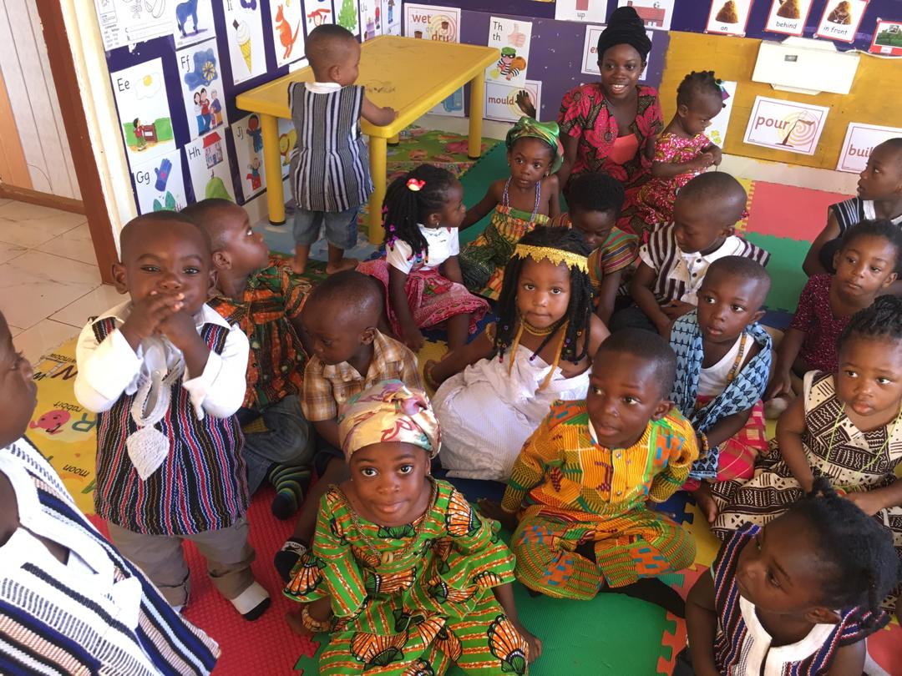
Parental and community: One Step Learning Preschool recognizes that children learn and apply their developmental skills at home and in the community as those are the places children spend the larger part of their time. Therefore, parental and community engagement activities will be encouraged frequently at various settings so that stakeholders can support and take active roles in the children’s daily learning. One Step Learning Preschool will garner support for parents and the community to recognize sponsors collaboration, contributions and the benefits of learning through play.

Meals, Transportation, Promotion:
Meals: Provide one meal each school day.
Transportation: Parents will be responsible for their children’s transportation back and forth.
Promotion: Create advertising signage; include sponsors names, local radio and media blitz. Partners and sponsors will be recognized in print, media, community activities and publicity opportunities.

Evaluation and Quality Assurance Measures
- Work hard for facility to open and become operational (anytime in 2020 – 2021)
- 40 enrolled pupils to start, 80 students in Year 1, and 100 by Year 2
- Sponsors secured to support the program and compound modifications completed on time
- Program undergoes a successful inspection and accreditation by the District Assembly
- Periodic evaluation and survey of children’s progress, finances, resources, program and technology
- Competencies of academic and support staff developed periodically and evaluated
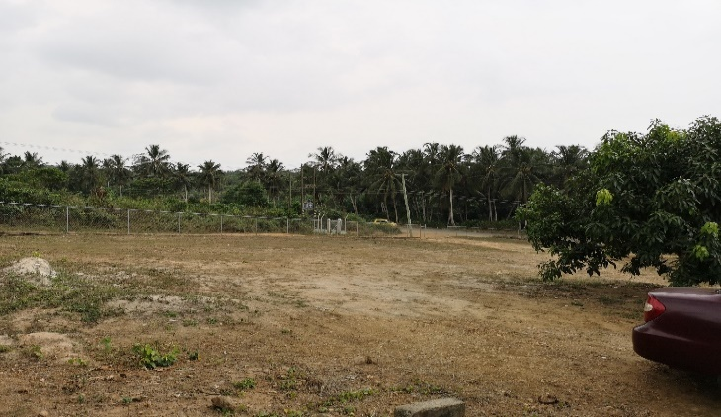 John & Celestina

Subscribers and Sponsorships
The founders, John and Celestina, have leveraged their existing 2012 building facilities and its compound in rural town Entumbil Ghana for Learning through Play purposes. The suitable existing “outer house” facilities portion are valued at USD$241,000 [Appendix 1]. Additional USD$ 178,000 is needed for materials and logistics to convert donated building to a safe preschool. The founders have committed to contribute additional USD$53,000 [Appendix 1] to kick start the project.
Therefore, USD$125,000 [Appendix 2] third party funds and materials are needed over a two-year period to make this niche rural Ghana project, an exemplary success and a quality story. Hence, sponsors, partners or donors who share in similar values of improving the quality of early childhood care and skills are needed to supplement and support the subscribers’ donation. A self-sustaining and financially matured institution is expected to breakeven in the third year through fees and government support. Any surplus will be reinvested in the program. After the first three years USD$10,000 will be required annually to maintain the quality of the program and services.

Stakeholders’ Opportunities
The subscribers realize the point that there is a huge benefit for them to listen and understand sponsors and stakeholders expectations, e.g. governments, corporations, individuals, and philanthropists while pursuing the charitable purposes. The intent is to make it a win-win opportunity for all stakeholders. Sponsors and volunteers will be recognized in print, media, community events and promotion activities.
Parents get a chance to pursue gainful employment or careers; childhood development is enhanced through niche resources available while learning through play. Area rural children, majority of who are girls, are empowered to advance literacy, prosperity and gender equality in the community. Sponsors and partners interests are consciously accounted for, jobs are created for rural Entumbil residents, and the founders’ dreams of operating in both Canada and Ghana are fulfilled. Put your name and social values on the plaque to advance rural children’s education and developmental skills.

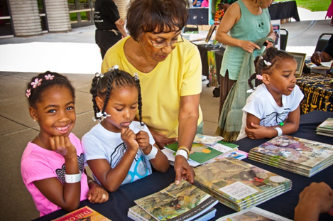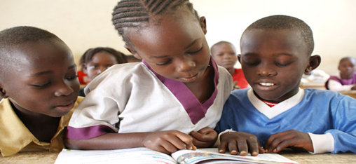

Sponsorship and Partnership Options
Any of these alternate forms of sponsorships or partnerships is negotiable:
- Seed funding for any of the identified equipment and material needs outlined in the business plan
- Philanthropists, individuals and corporate donations for equipment, materials, and staff capacity.
- Direct outright partnership funding with the existing subscribers, Partner/Sponsor Agreements.
- Cash and/or in-kind contributions towards materials, equipment and professionals, training etc.
- Organized fund raising activities (including Go Fund Me or something similar).
- Award contract work to community residents to work on a sponsor’s contribution.
Donations of used equipment, materials’ goods and services are welcome.
OSL will gladly do a presentation [click here] for you if invited
“Play elevates talent and abilities” – John Hagan
Thank You for your generosity.

STRATEGIC FRAMEWORK

Context
A Canadian-Ghanaian couple who have lived in Canada for 39 years wants to advance the education of rural children who cannot afford the cost of daycare facilities. The couple has raised three children and seven grandchildren in Canada, who have all experienced various learning through play models. The couple has donated a 2012 building with a large compound in rural Entumbil, Ghana towards learning through play daycare centre for 2 – 6 year old rural children. The facilities is valued at USD$241,000. One Step Learning Opportunities Centre (OSL), an incorporated non-profit Canadian charity will manage, direct and control the charitable activities in furtherance of the charitable purpose. This 2020 -2024 Strategic Plan will guide OSL to establish, maintain and operate the play-based daycare centre.
The OSL subscribers are looking for donors, partners and sponsors who share in the vision to collaborate with them to provide opportunities for rural children, especially girls to develop their skills and lifelong capabilities. Partners like you and your organization may contribute or donate any of the items listed in Table 2, Appendix 2 and Appendix 1 of the Strategic Plan. Canada tax deductible receipts are available.
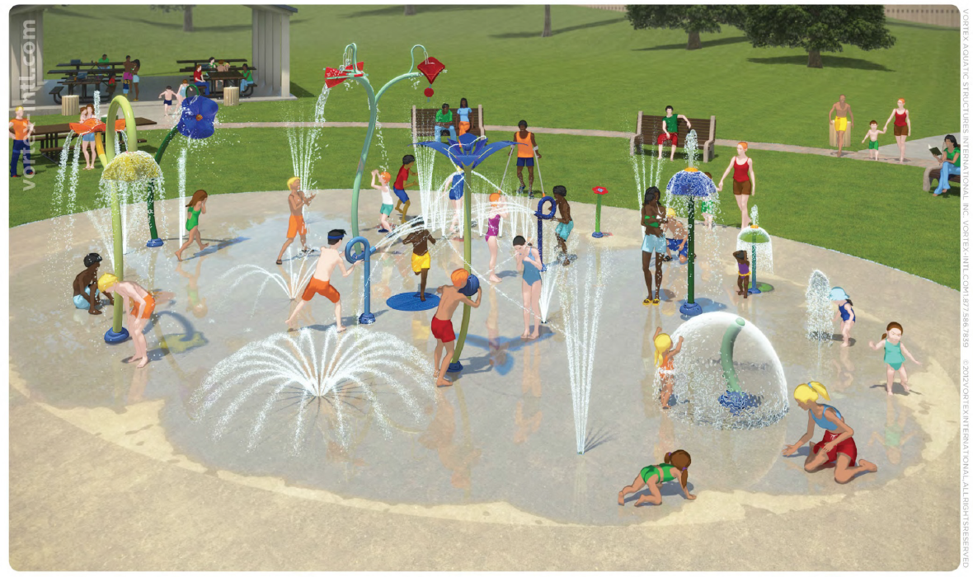

Mission, Vision, Outcomes
Our Purpose and Mission
- To advance education by establishing, maintaining and operating a learning through play day care centre in Entumbil, Ghana
- To undertake activities ancillary and incidental to the attainment of the above-mentioned charitable purpose
Our Vision
- Elevate rural children’s talent and abilities one town at a time in Entumbil, Ghana.
- Create play-based learning opportunities for rural children, especially girls to develop lifelong skills and advance literacy, prosperity and equal opportunity in the community.
- To appreciate partners and donors generosity to create learning opportunities for rural children.

Outcomes
- A structured Learning through Play empowers rural children to elevate their talent and abilities.
- Kids get opportunity to learn through play, be happy, healthy and become learners of tomorrow.
- The daycare will enable the children’s parents to seek gainful employment and careers.

Legislation, GES and District Assembly
Ghana Children’s Act of 1998, Act 560, outlines guides for day care centres, and early childhood care development (ECCD) institutions. Any preschool designed to give regular instruction to children below age six is under the supervision of the Ghana Education Services (GES). Day cares and pre-academic centres are required to apply for permits. The Ministry for Women and Children Affairs (MOWAC) led the early childhood care and development (ECCD) policy in Ghana.
District Assemblies issue by-laws and guidelines for the operation of day care centres within their districts, and the Department of Social Welfare inspects each centre at least once every six months. District Assembly Social Services units receive inspection reports and enforce any required standards.

Risks, Constraints and Mitigation
- Absence of subscribers in Ghana. [Mitigation: Move from Canada to live in Ghana upon securing leverage support. Proceed to Ghana 5 months prior to start, manage and oversee project logistics].
- Cash flow is low. Subscribers’ USD$53,000 will be available over two years to 2021. [Start buying affordable items now. Seek sponsors, partners, and philanthropists. Stagger project over 2 years].
- Technology networks (Broadband) connectivity is challenging in rural Ghana. [Tap into sponsors resources. Talk to telephone companies and other corporations. Others have done it, seek mentors].
- Fees affordability is challenging for rural folks. GHC$150/month is not enough to make the program breakeven. [Tap into sponsor resources. Advocate parents to volunteer in kind. Ghana Government may sponsor some elements after 3 years e.g. teachers’ salaries and feeding for private schools.]
- Lack of subsidies for parents. [Tap into sponsors resources. Engage parents for ideas, volunteerism]

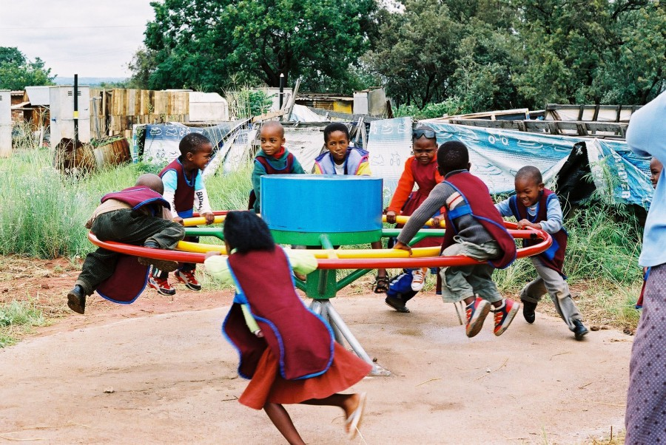

Strategies
- Advance children’s education using play-based learning methods, staff, materials, and equipment
- Incorporate a tax registered charity, One Step Learning Opportunities Centre to lead the project.
- As founders and subscribers, donate existing infrastructure facilities to advance the purpose.
- Seek sponsors or partners and general donors. Issue CRA tax deductible receipts.
- Convert facilities and spaces around house into playground and fields (see Appendix 2).

Governance Oversight and Management
The founders plan to live in both Canada and Ghana. They will actively oversee the operation of the project. John a CPA, CMA, CGA, CIA, CRMA, BAccS is a chartered professional accountant and a professional certified internal auditor. He has some 30 years work experience in Canada and seven years in Ghana. Celestina has worked in dietary in Canada for over 20 years and over ten years as dressmaker in Ghana. The couple has valuable experience in children developmental skills. Their children and seven grandchildren have experienced benefits of preschool play-based concepts.
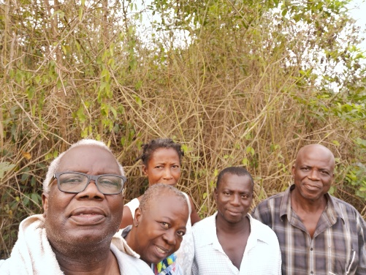
The Board of Directors will be revised to consist of the 2 subscribers, 2 or more sponsors (if any), 2 parents, and the Principal Administrator. Senior management (Executive of the Board) with signing authority shall consist of the either of 2 subscribers, 1 sponsor and the Principal Administrator as Secretary/Treasurer, based on established internal controls. Project subscribers are very open to external audits, evaluations, Partnership/Sponsorship Agreements with terms and conditions, as well as, periodic progress reports and communication with collaborators.
The Principal Administrator shall manage the day-to-day play-based learning environment. This includes development of play-oriented curriculum and stimulating materials that promote rural kids developmental progress. Her/his duties shall include the establishment of systems and procedures that meet legislation and regulatory requirements. She/he will risk manage facilities, internal controls, security, administrative management policies, and daily operations. The Principal Administrator will oversee academic and support staff; and promote capacity building and professional development.
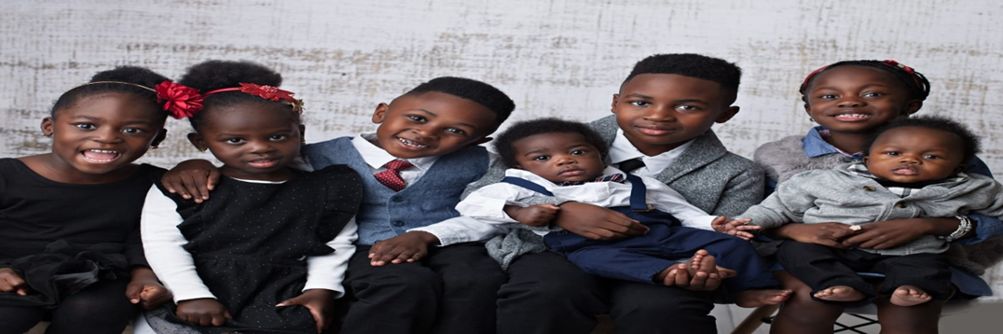
Founders’ seven grandchildren have developed lifelong skills from learning through play, Awesome!

Conversions Required Budget
Item/Activity Description | Value in USD$ | Timing
- Complete outstanding wire fencing - 120’ and 140’ L-Shape, so 260’ of wiring required (USD$7k). Entrance vehicle gate (USD$1k). Plus put a Security shed/room (USD$2k) | 10,000 | Immediate
- Add boys peeing bowls to the half toilet. Plus any plumbing | 3,000 | Immediate
- Landscape Playground area vacant land. Major landscaping. That is front fence towards the back fence up to 10 feet from the outer house back wall. Grading, till, put grass, | 10,000 | Year 1
- Plant trees, plant fruits, sand in areas, playground, make island-type sheds etc. Incorporate as hands-on learning projects for students as environmental /garden project. | 6,000 | Year 1
- Create an Assembly/Muster area by the standing pipe and mango tree outside, say 10 feet from the house. Place concrete or use marble as a skirt around the house all the way down to the private residence entrance (USD$12k). Plus the front area underneath the sitting area verandah (USD$8k). Put concrete drainage at the back of the outer house (USD$5k) | 25,000 | Year 1
- Extend roofing to cover marbled and Assembly/Muster areas. Put in Eaves trough around the house to ensure proper drainage away from the school and house | 14,000 | Year 1
- Seek donors for Playground equipment and transportation | 40,000 | Year 1
- Develop/landscape the backyard area into a school play field for various games e.g. soccer, basketball, volleyball, tennis | 6,000 | Year 2
- Erect big signage for promotion, include sponsors & partners | 2,000 | Immediate
- Any street and access improvement work | 1,000 | Immediate
- New Painting for the daycare area outer house | 4,000 | Immediate
- Equipment & accessories - see separate list below | See below
TOTALs for Conversion Modifications | USD$ 121,000
Sweat Equity / Volunteers in-kind match | USD$ 121,000

Thank You for your generosity.

Cash flow summary
Funding | Immediate | Year 1 | Year 2 | Total
Daycare facilities conversion costs:
Founders additional donation | USD$ 53,000 |  |  | USD$ 53,000
Sponsors/Partners/Donors | USD$ 111,000 | USD$ 8,000 | USD$ 6,000 | USD$ 125,000
Total set up capital costs | USD$ 164,000 | USD$ 8,000 | USD$ 6,000 | USD$ 178,000
Academic Program Operations:
Program fees and income |  | USD$72,000 | USD$72,000
Academic program expenditure |  | USd$72,000 | USD$72,000
Seek In-kind donations for: Playground Equipment, Sports materials, Staff training, Toys, Electronics, Tablets, Promotions, Sanitary Products, Materials, Furniture, and day to day operations etc.

Materials and Accessories Budget
Item/Activity Description | Value in USD$ | Timing
- Provide Classroom & Office furnishings e.g. lockers, fans, AC | 3,000 | Immediate
- Computer 30 tablets and 8 laptops, Internet access | 5,000 | Year 1
- Toys, White Boards, sports cleats, runners | 1,000 | Immediate
- Good strong Used Vehicle (Truck or SUV) | 25,000 | Immediate
- Safety/emergency equipment and/or avenues arranged | 1,000 | Immediate
- Plates, cutlery, cooking utensils, | 2,000 | Immediate
- Fridge, Stove, Dishwasher, Washer & Dryer | 5,000 | Immediate
- Toiletries: soap, sanitation, mops, toilet rolls, dish soap etc. | 1,000 | Immediate
- Audio/PA system, 3 TVs on compound in hall & 1 classroom | 3,000 | Year 1
- Electronic/Electrical work and connections | 2,000 | Immediate
- Office: Cabinets, office desks, tables, phones, printers | 2,000 | Immediate
- Furniture for Teachers & pupils Unit rooms : 4/5 people round tables - 40, chairs 120, Teachers table and desk - 6 | 4,000 | Immediate
- Teachers training and development | 3,000 | Immediate/Yr1
Conversion costs – see list above | See Above
TOTALs Equipment and Accessories | USD$ 57,000

Monthly Operating Funds
Item/Activity Description | Value in USD$ | Timing
Teachers & Support staff Salaries (GHC (10x7) (5x1,500)) approx. | 3,000 | Year 1…
Communications, accounting, legal and administration | 1,500 | Year 1,,,
Utilities | 1,000 | Year 1…
Facilities security, maintenance | 500 | Year 1…
Total monthly expenses | USD$ 6,000
Expected Revenues
School Fees average (GHC (80 x GH$150) = 12,000 so approx. | 2,400 | Year 1…
Feeding (GHC (160 x 20 days) = 3,200) so approx. | 640 | Year 1…
Grants, donations, contracts, sponsors, in-kind activities | ?? | Year 1…
Total Remunerations monthly, say | USD$

Donations Welcome e.g. Professionals, Volunteers, Cash, Materials, Toys, Equipment, Furniture, Books, Sanitary products, Electronics, Advice, Feedback…
Sponsors and partners will be recognized in print, media sites, community activities and publicity opportunities.
Cash donations by Interac- e-transfer okay to jcbhagan@telus.net or taxreceipt@onesteplearning.org . You can contact us for advice. Thank you for your time. One Step Learning is a Canadian registered charity under the Income Tax Act eligible to issue official donation receipts. CRA charity #

Financial Projections

Appendix 1: Founders’ Contributions
Items | Value in USD$
Founders Existing Contribution  Outer House consists of: | 241,000
4 identical Rooms/Units 14’x15’ each@ USD$25k x 4 | 100,000
1 Large Hall for Office Admin & storage etc. 22’x15’ | 50,000
1 kitchen 15’x15’ | 40,000
3 Toilets (designate 2 for girls and 1 for boys). [Later turn half toilet into boys peeing bowls | 30,000
3 Bathrooms @USD$7k x 3 | 21,000
A separate entrance | --
Total existing contribution | 241,000
Founders’ Additional Funding :
Finish Fencing & security Qtrs. | 10,000
Boys Peeing Room & Plumbing | 3,000
Used Vehicle SUV/Truck | 25,000
Big Promotion Signage | 2,000
Street access improvement | 1,000
New Painting | 4,000
New Fridge, Stove, Washer &Dry | 5,000
Toiletries | 1,000
Plates and Cutlery, Utensils etc. | 2,000
Additional Funding contribution | $53,000
Sweat Equity/Volunteers match | $53,000

Reconciliation of Project Capital Funds
Repairs & Conversion  Tools & Accessories  Total | USD$ 121,000  USD$ 57,000  USD$ 178,000
Founders’ new Contribution  Sponsors Funds  Total | USD$ 53,000  USD$ 125,000  USD$ 178,000
Volunteers match | USD$ 178,000

Appendix 2: Sponsor Funds Needed
Items | Value in USD$
3rd Party Existing Contributions | 0 - none
Third Party Sponsorship sought:
3rd Party Funding Needed for:
Landscaping Playground | 10,000
Plant trees, Sheds… | 6,000
Playground Equipment | 40,000
Assembly area flooring | 25,000
Extended Roofing | 14,000
School Backyard fields | 6,000
Audio/PA System, TV Monitors | 3,000
Electronic & Electric connections | 2,000
Classrooms furnishings | 3,000
Computers, tablets, | 5,000
Office furniture, printers, tools | 2,000
Teachers development | 3,000
Safety/Emergency | 1,000
Toys, gadgets, White Board | 1,000
Unit Classrooms furniture | 4,000
TOTAL Sponsorship needs | $125,000
Sweat Equity/Volunteers match | $125,000

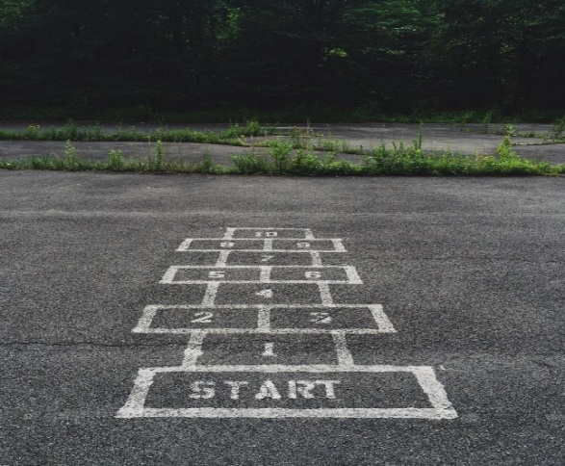

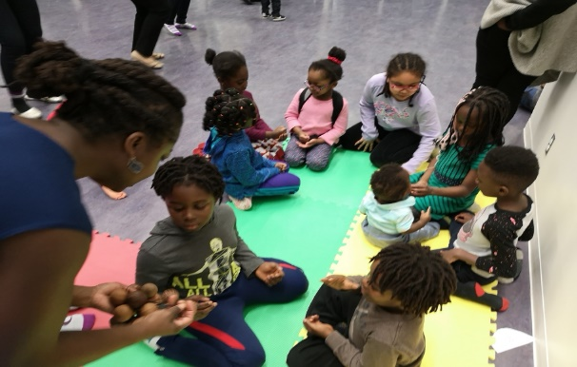  “Play elevates talent and abilities” - John Hagan  OSL will gladly do a presentation [click here] for you if invited | Thank You for your generosity.  Business/GST number: 771608478  CRA Charity Registration #: ?771608478RR0001?  Donation to OSL [taxreceipt@onesteplearning.org]
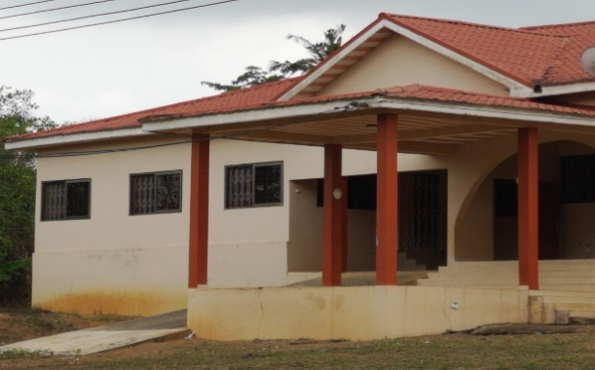 | 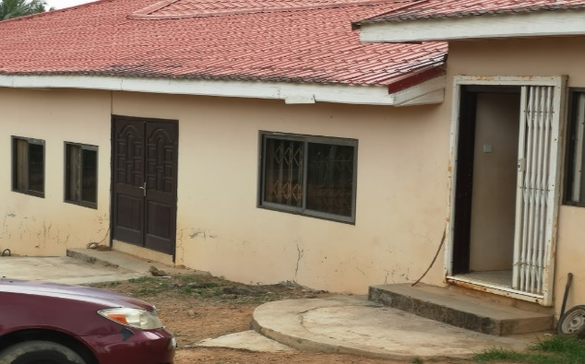

Contacts
John Hagan, Founder and President
Celestina Hagan, Co-Founder
Phone: +1 (780) 717 4055

Email: jcbhagan@telus.net or contact@onesteplearning.org

Mailing Address: 15219 – 44 Street NW Edmonton Alberta Canada T5Y 3C4

Entumbil Location: 60 First Light Entumbil, Central Region Ghana

